**EXPERIMENT NUMBER 9**

| Name of Student: Sangeet Agrawal | PRN: 21070122140 | Section: CS-B3 |
| --- | --- | --- |

**Title**: Report on SIEM SPLUNK and NESSUS based on workshop conducted on 13-14 September 2024.

**Objective:** To make students understand SIEM SPLUNK and NESSUS tools.

**Theory:**

1. SIEM SPLUNK:

Splunk is a tool for Security Information and Event Management (SIEM). It collects, monitors, and analyzes data from various sources, like logs and servers, to help detect security threats in real time.

* Data Collection: Gathers data from different sources like servers and apps.
* Real-Time Monitoring: Monitors security events as they happen, enabling quick detection.
* Alerts and Dashboards: Custom dashboards and alerts help visualize data and notify you of issues.
* Incident Response: Helps investigate security incidents by allowing fast searches through logs.

1. NESSUS:

Nessus is a vulnerability scanner used to detect security weaknesses in systems.

* Vulnerability Scanning: Identifies known vulnerabilities like outdated software or misconfigurations.
* Compliance Checks: Ensures systems meet security standards like PCI-DSS.
* Reports: Provides detailed reports on vulnerabilities and fixes.
* Plugins: Regular updates help detect new vulnerabilities.

**Installation:**

1. **Installing SPLUNK on macOS Apple Silicon:**

SPLUNK wasn’t working on either the Windows or Linux OS of the college desktops, nor on my laptop.

1. **Installing NESSUS on macOS Apple Silicon:**

Nessus has a native macOS installer, and it works well with Apple Silicon. Follow these steps to install and set it up.

Steps:

1. Download Nessus for macOS:
   1. Go to the official Nessus download page: [Nessus Downloads](https://www.tenable.com/products/nessus/select-your-operating-system).
   2. Choose the macOS version and download the installer package (.pkg file).
2. Install Nessus:
   1. Open the .pkg file and follow the installation prompts.
3. Start Nessus:
   1. Once installed, open Terminal and start the Nessus service:

| sudo /Library/Nessus/run/sbin/nessusd |
| --- |

1. Access Nessus:

Open your browser and go to https://localhost:8834. Follow the setup steps to configure your account and run your first scan.

**Screenshots for Nessus:**

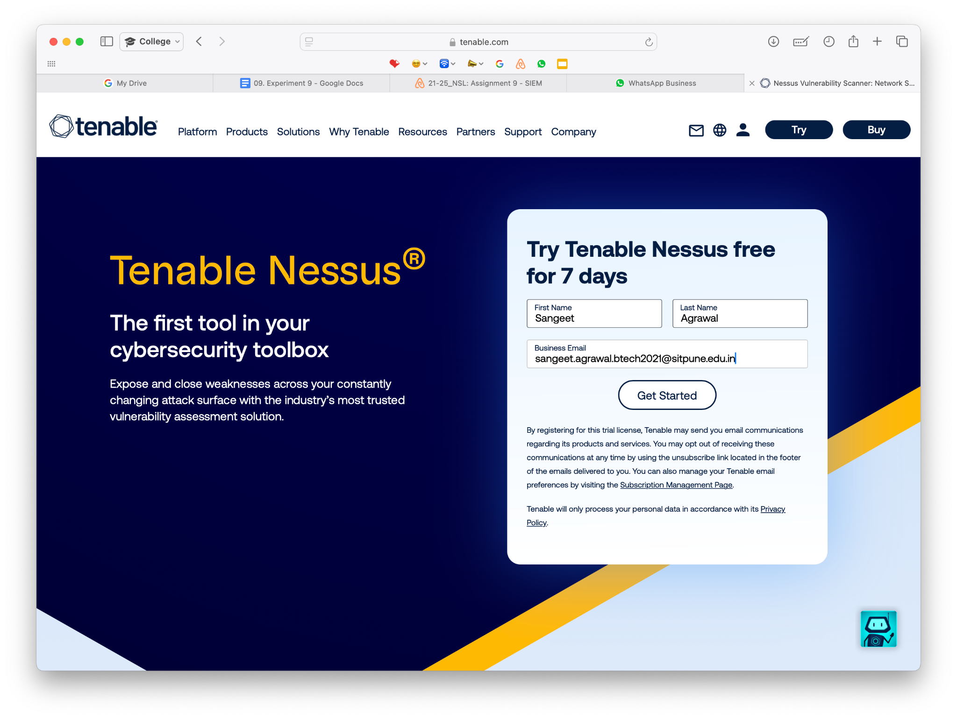

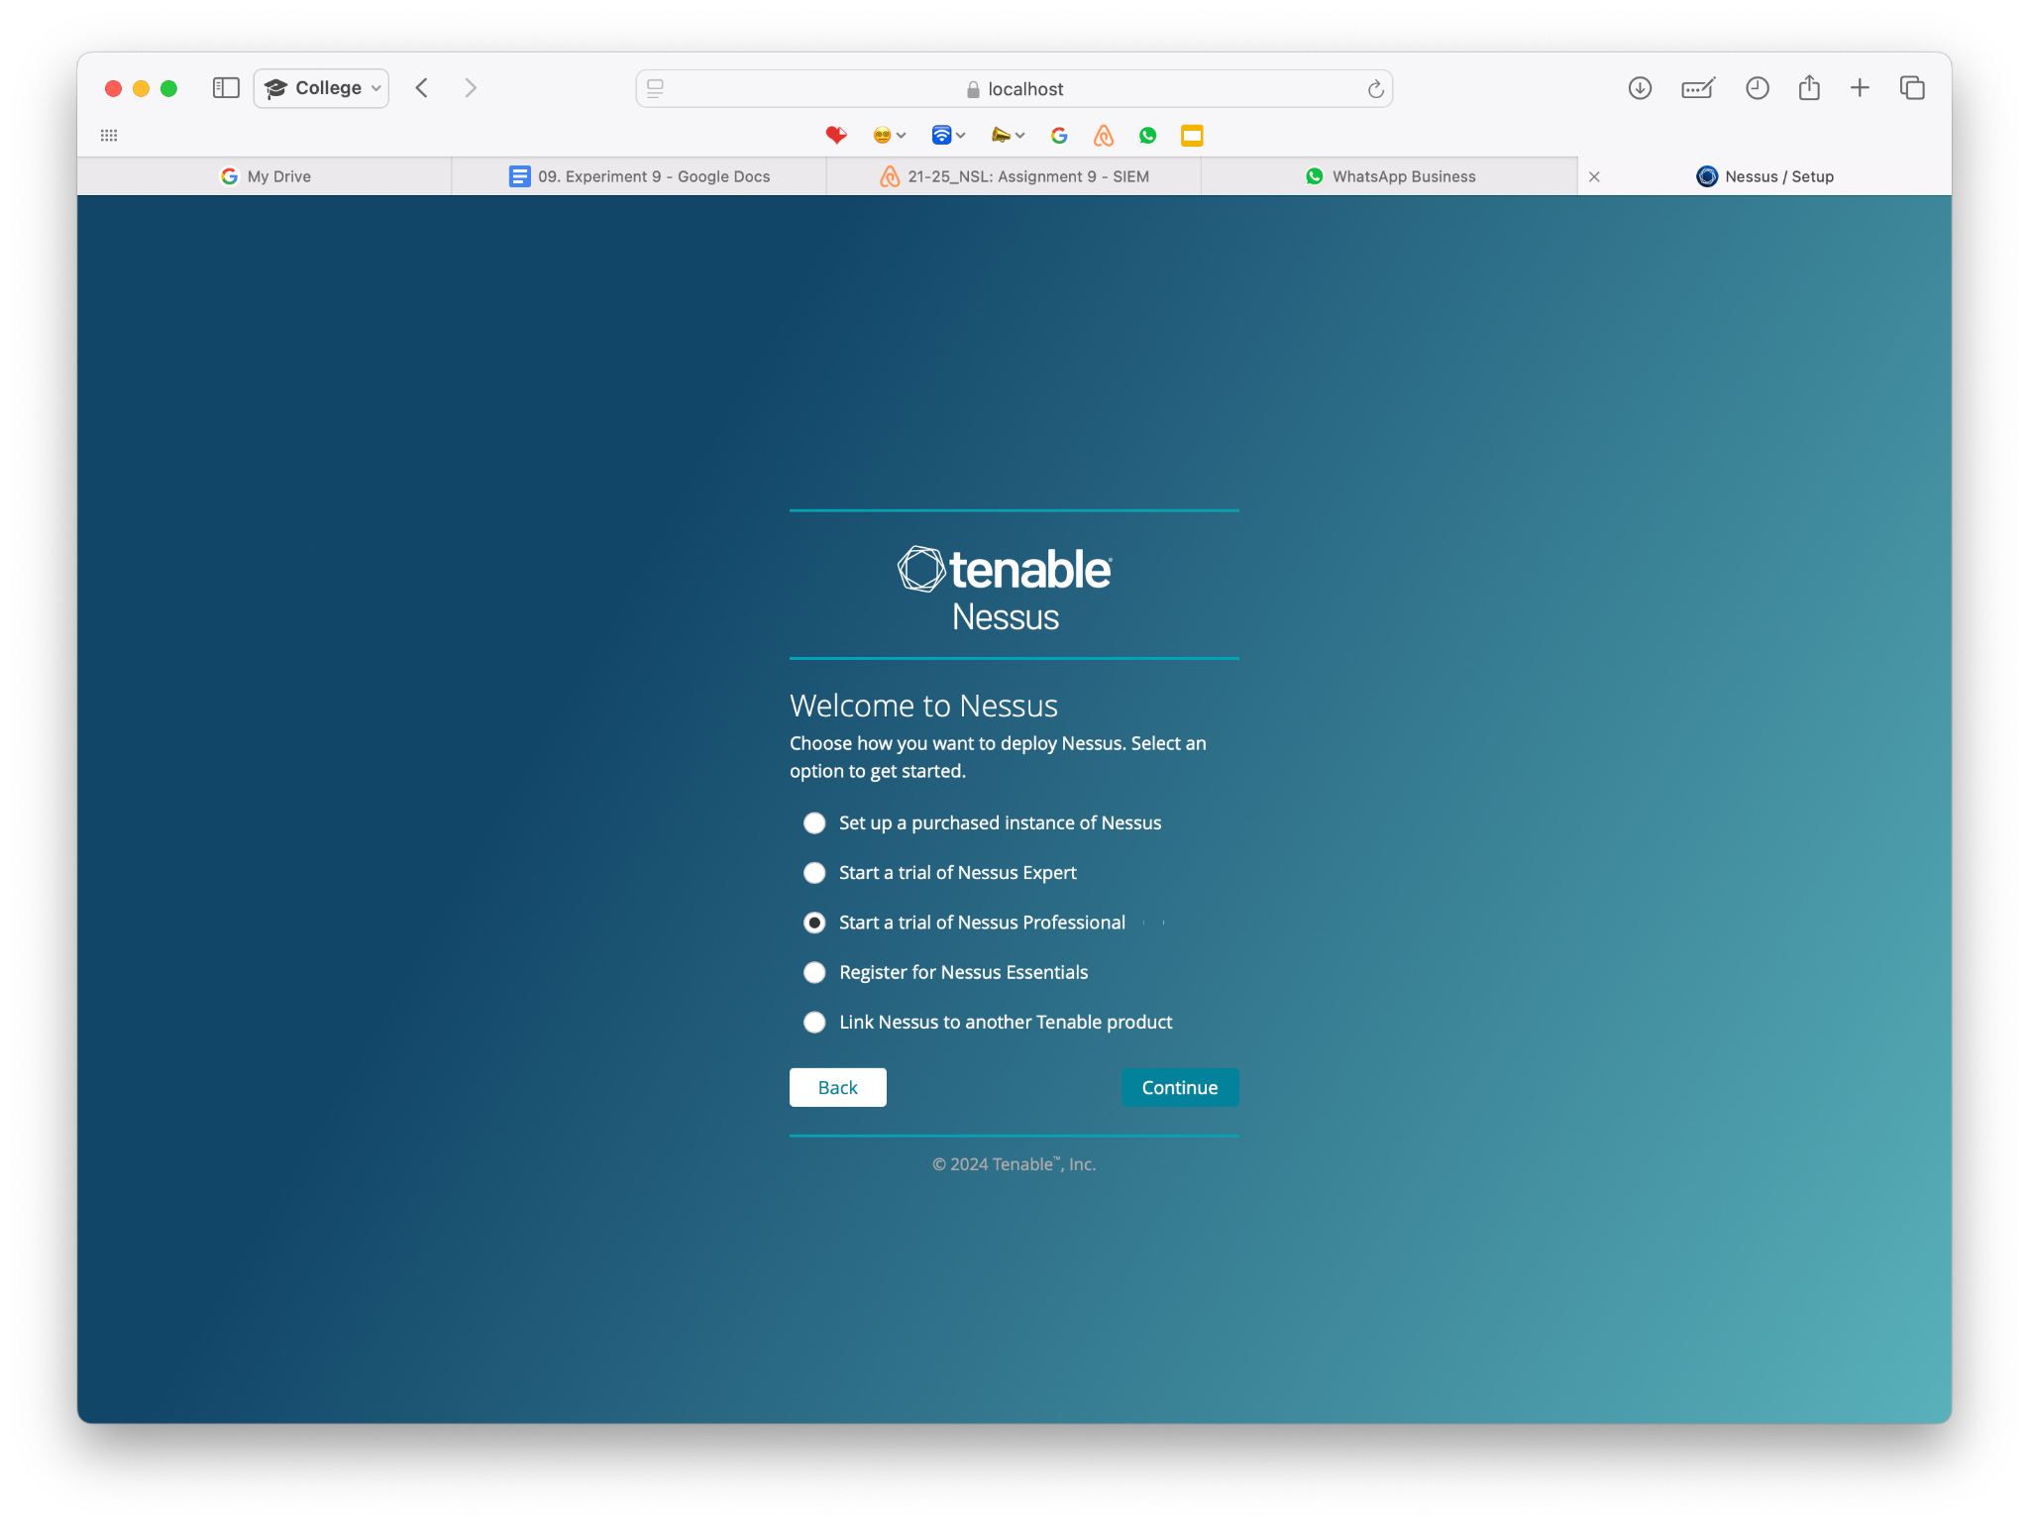

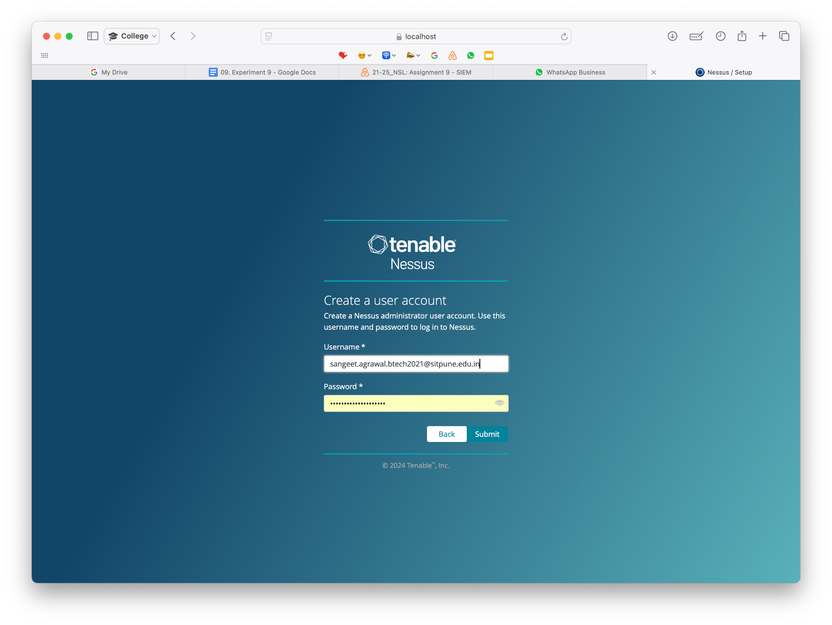

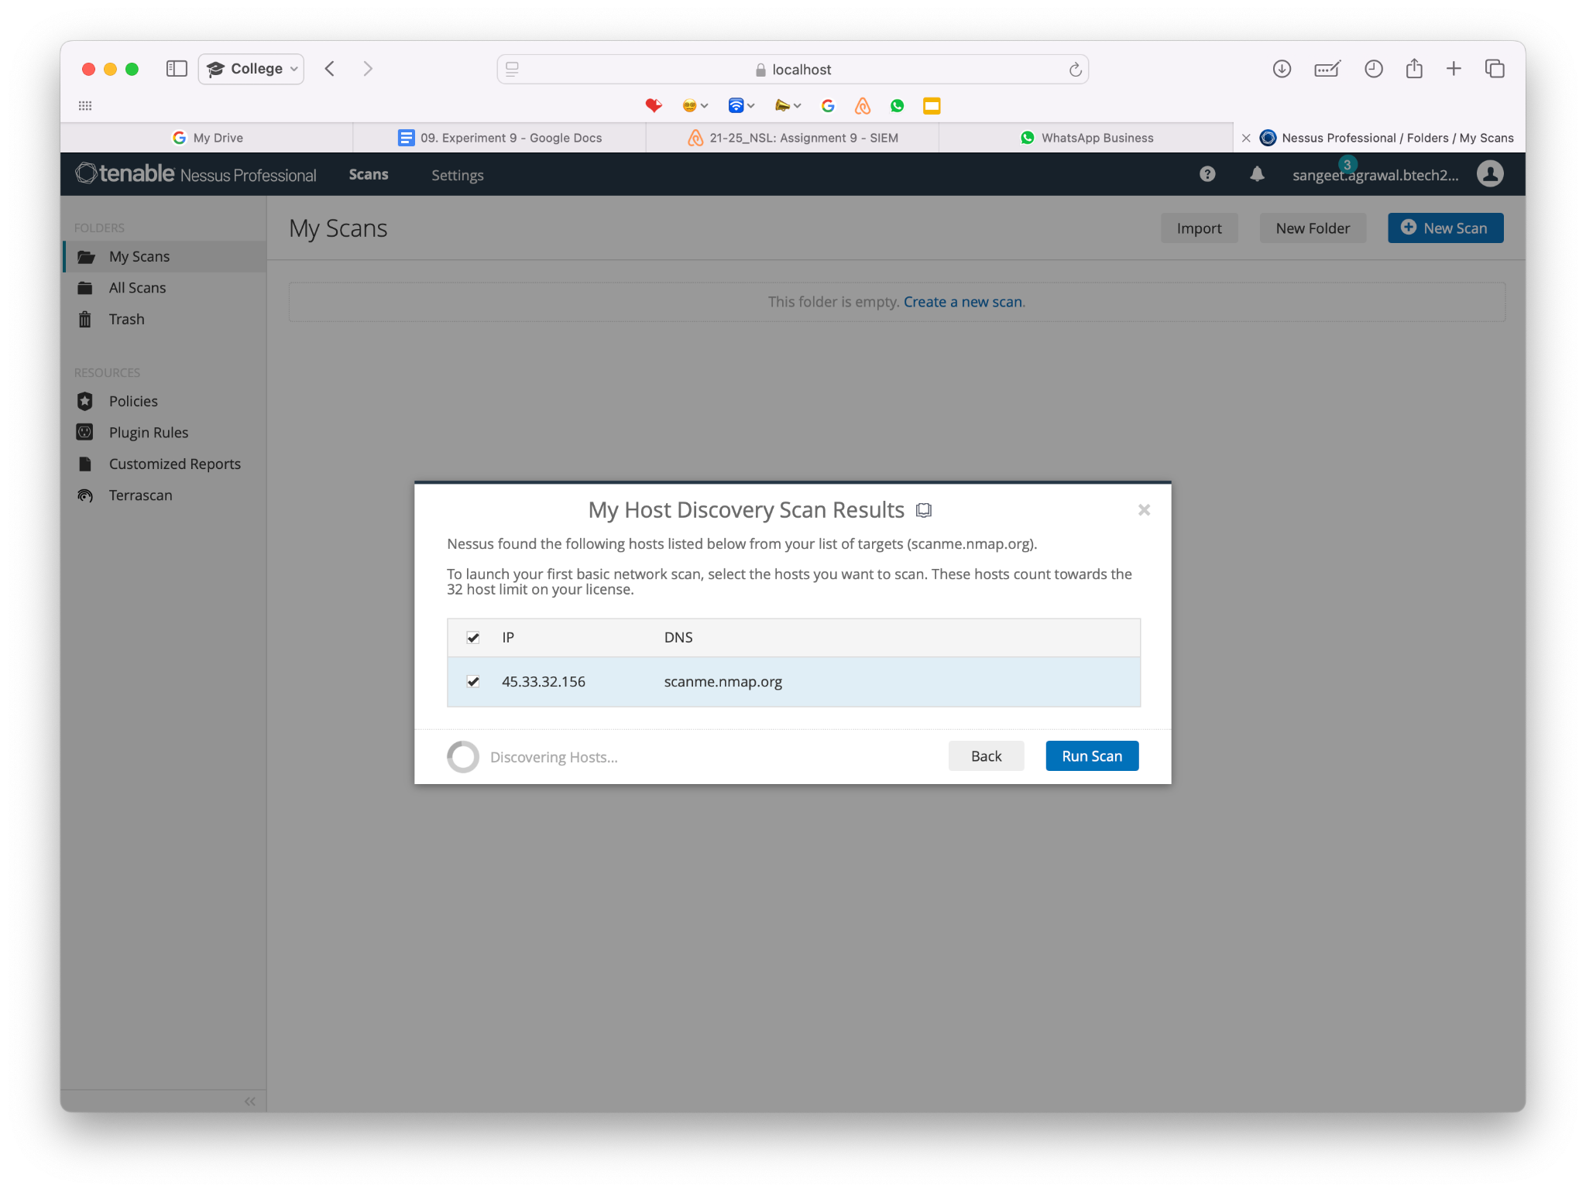

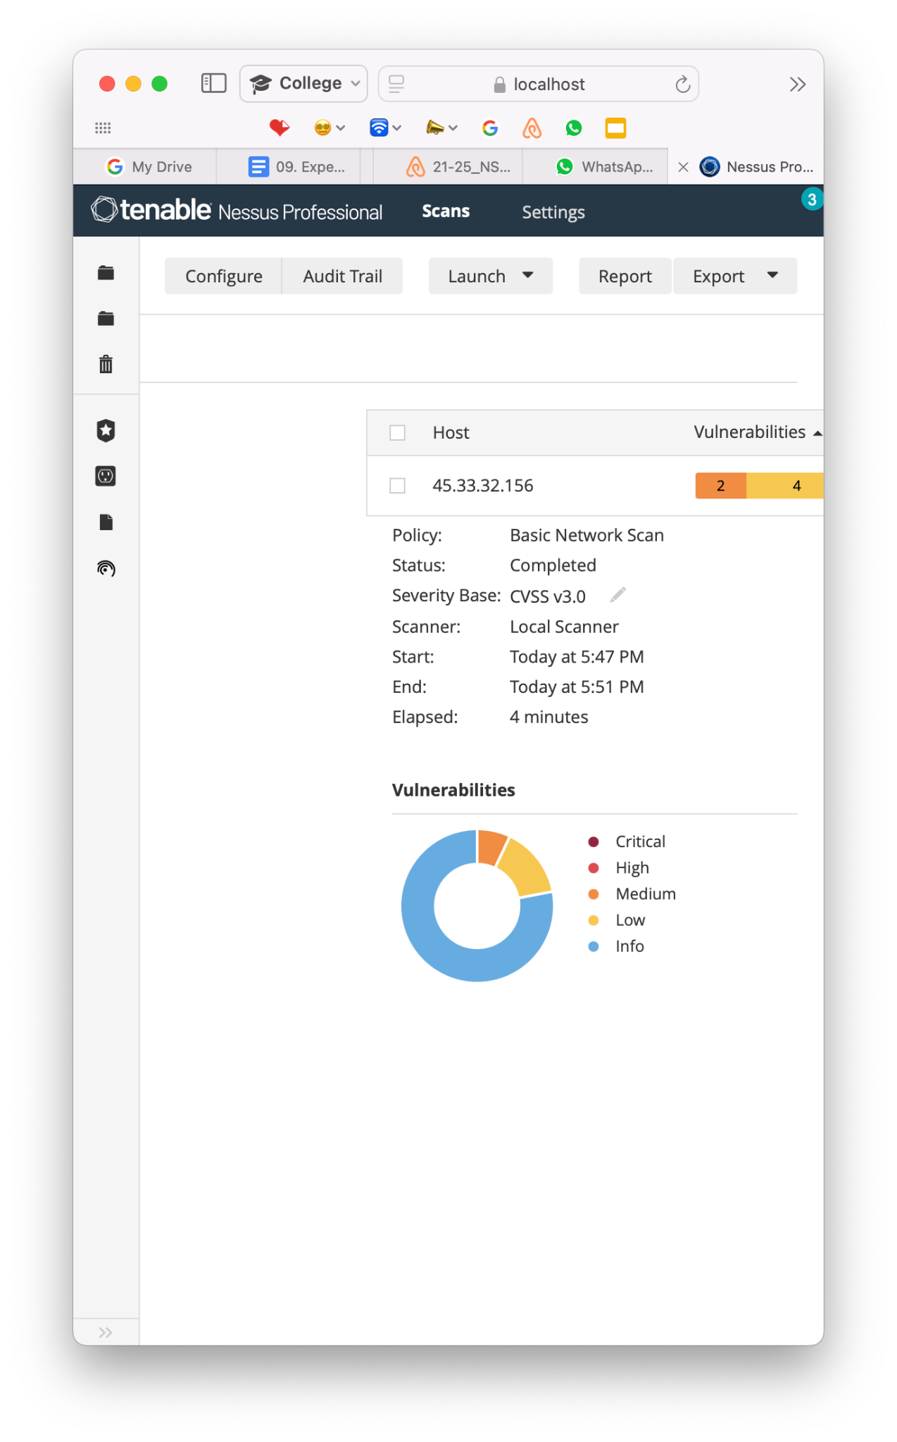 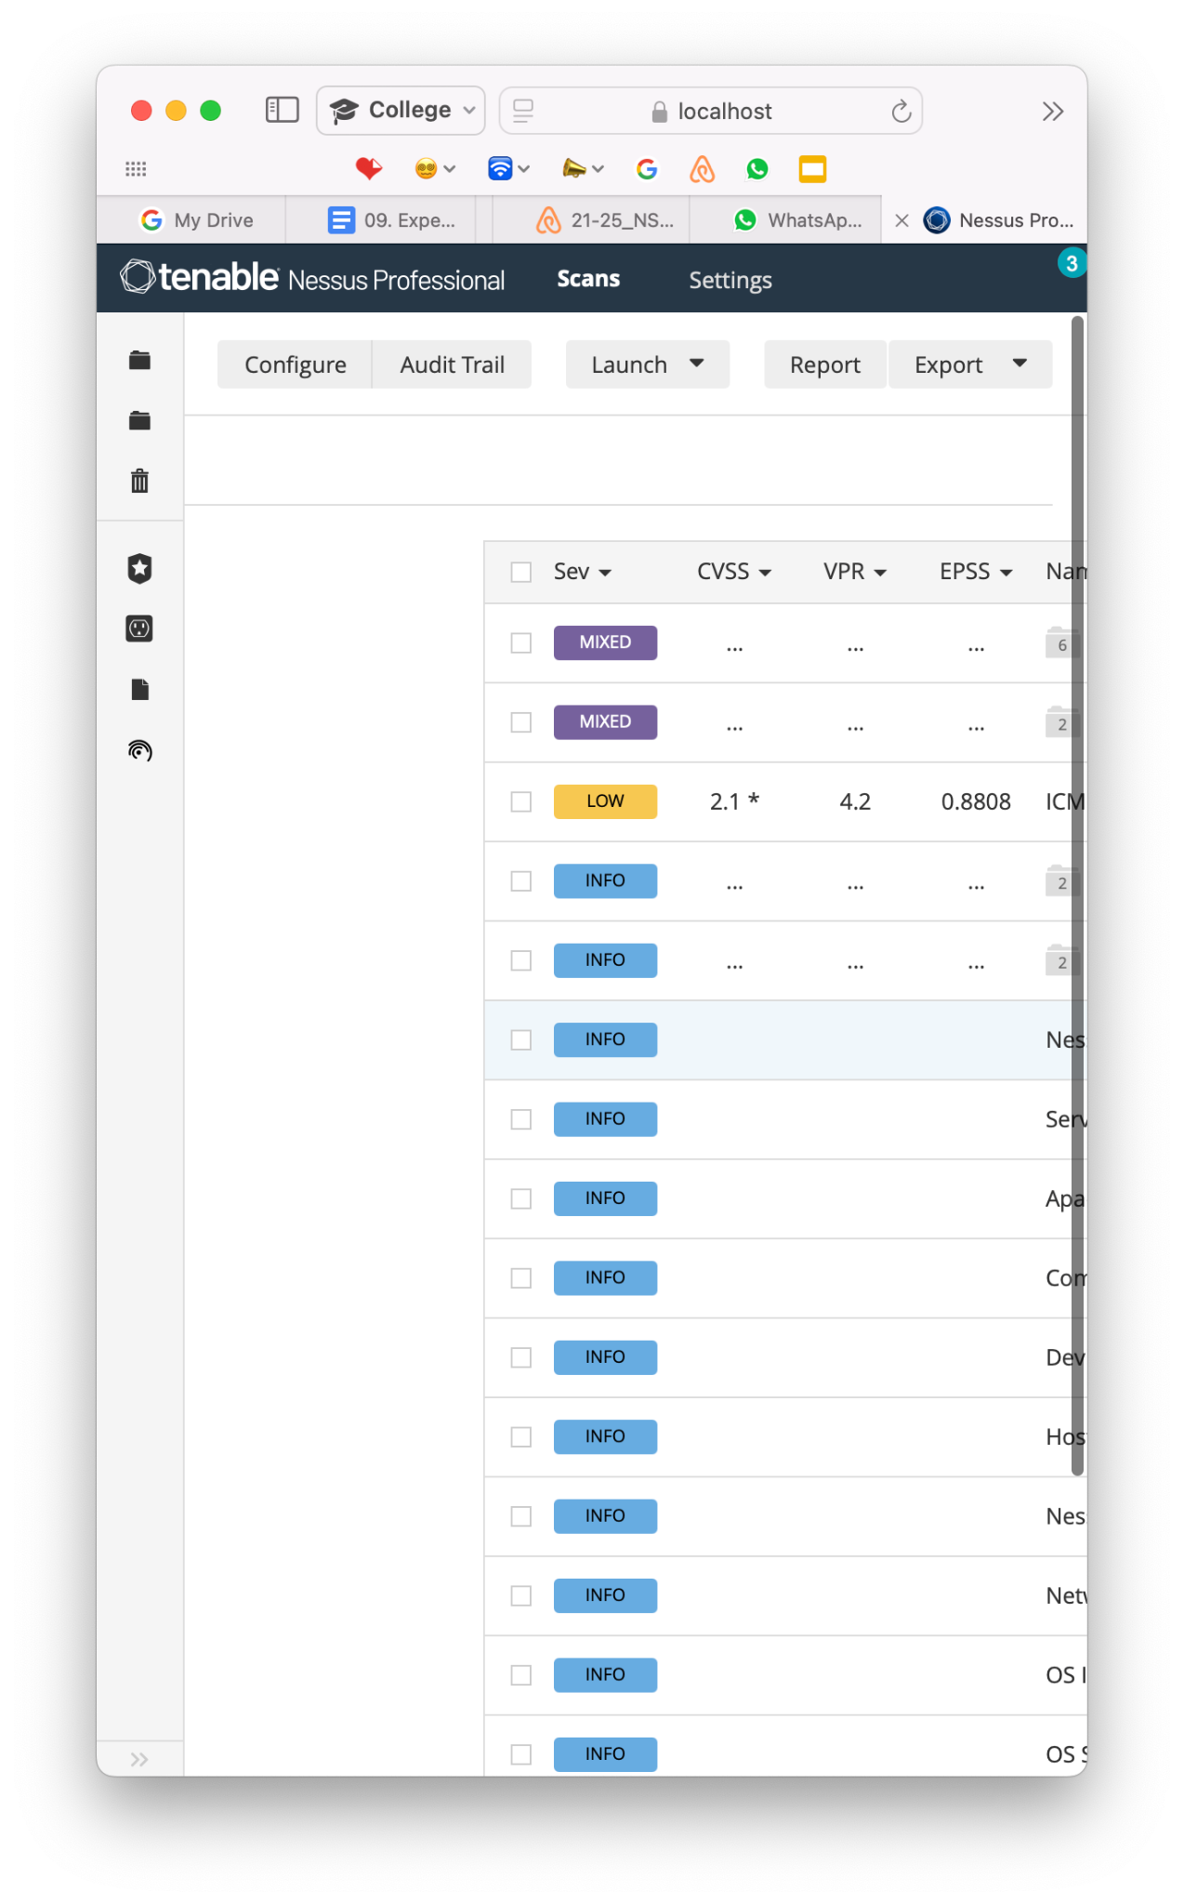

**Conclusion:**

The workshop on SIEM SPLUNK and NESSUS provided valuable hands-on experience with two key tools in the cybersecurity domain. Splunk’s log monitoring and real-time analysis capabilities, coupled with Nessus’s vulnerability scanning, offer comprehensive solutions for enhancing system security.

**Note:** Students are suggested to use Linux OS-based tools or free Windows OS-based tools.